**LAB PROGRAMS DAY 2 (05/06/24)**

1. **Reverse of a given number using recursive.**

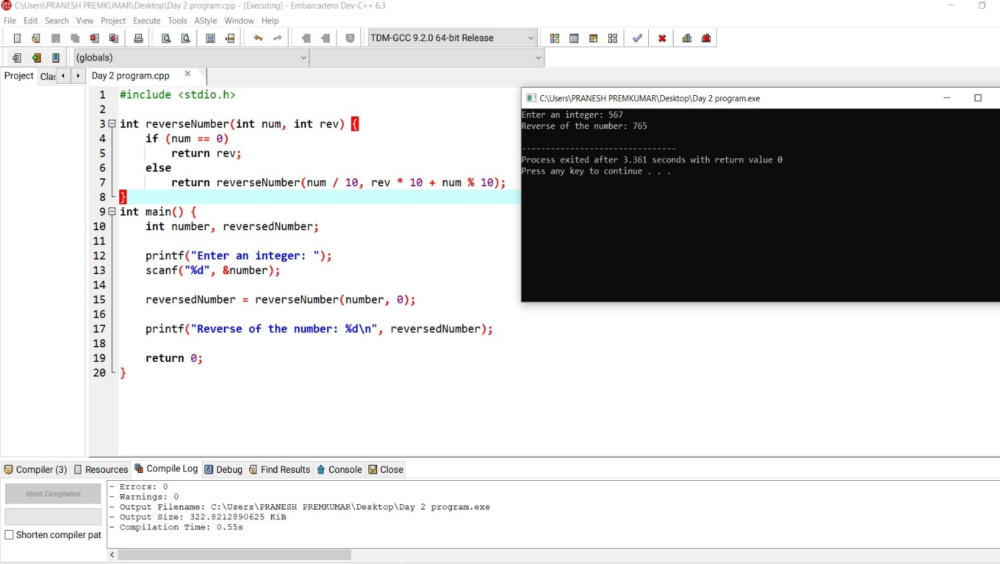

**2. Perfect Number**

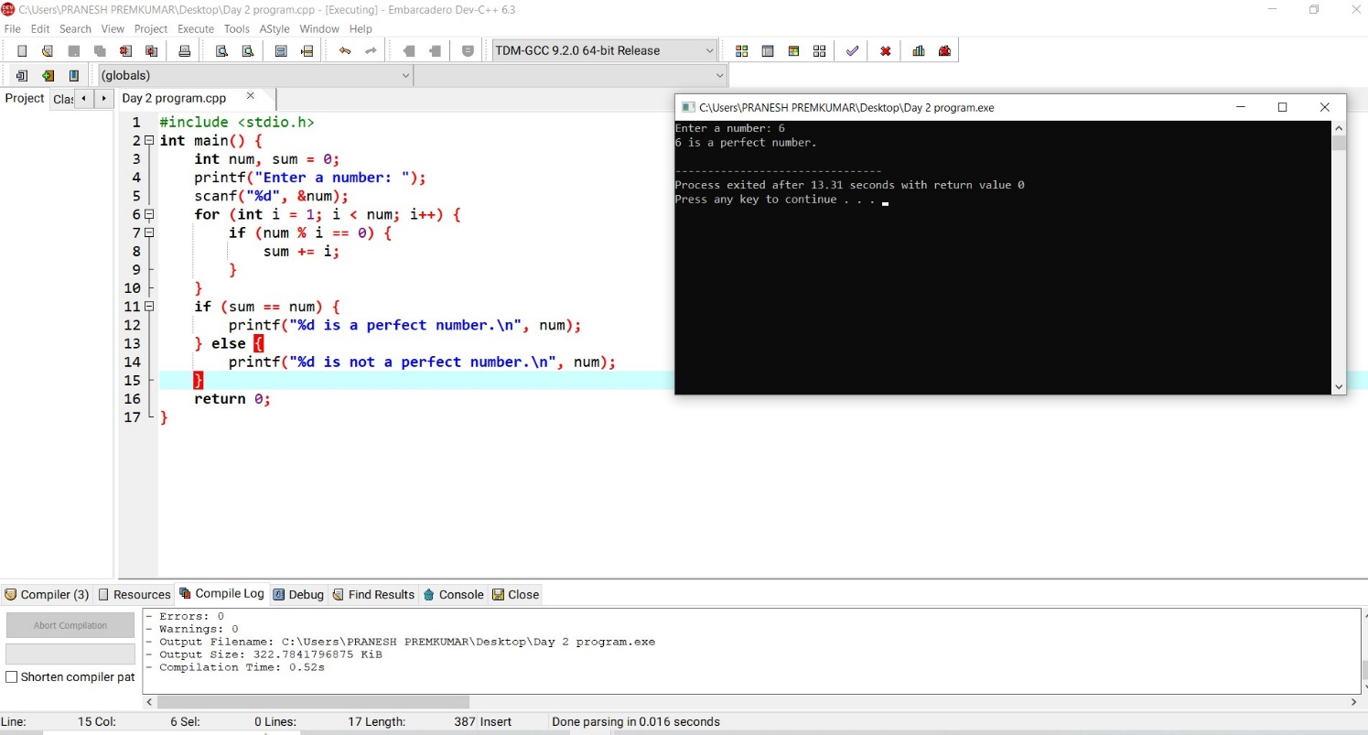

**3. Analyzing The Time Complexity**

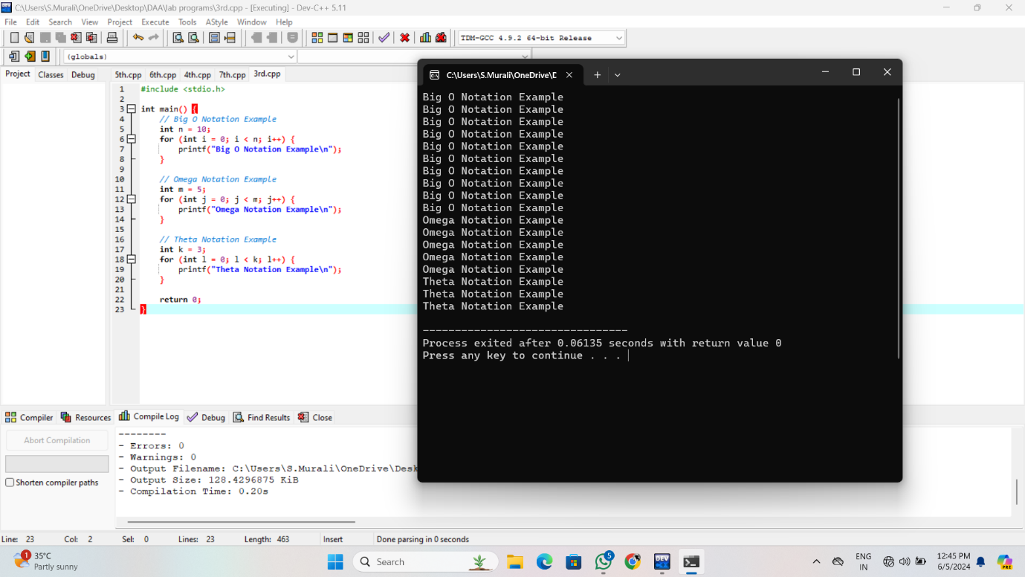

**4.** **Mathematical Analysis of Non-Recursive and Recursive Algorithms.**

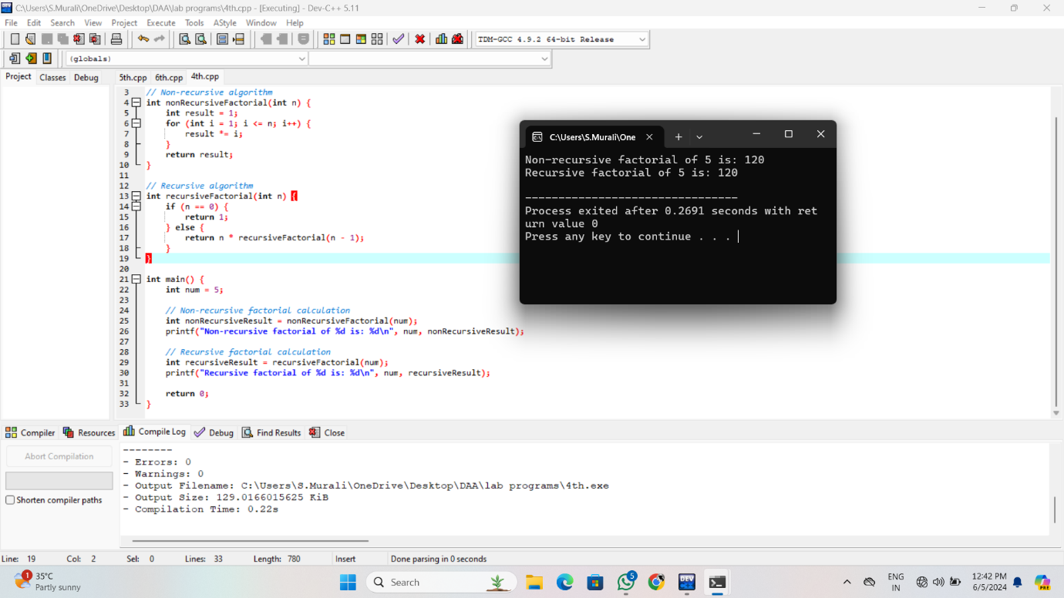

**5.** **Recurrence Relations Using the Master Theorem, Substitution Method, And Iteration Method.**

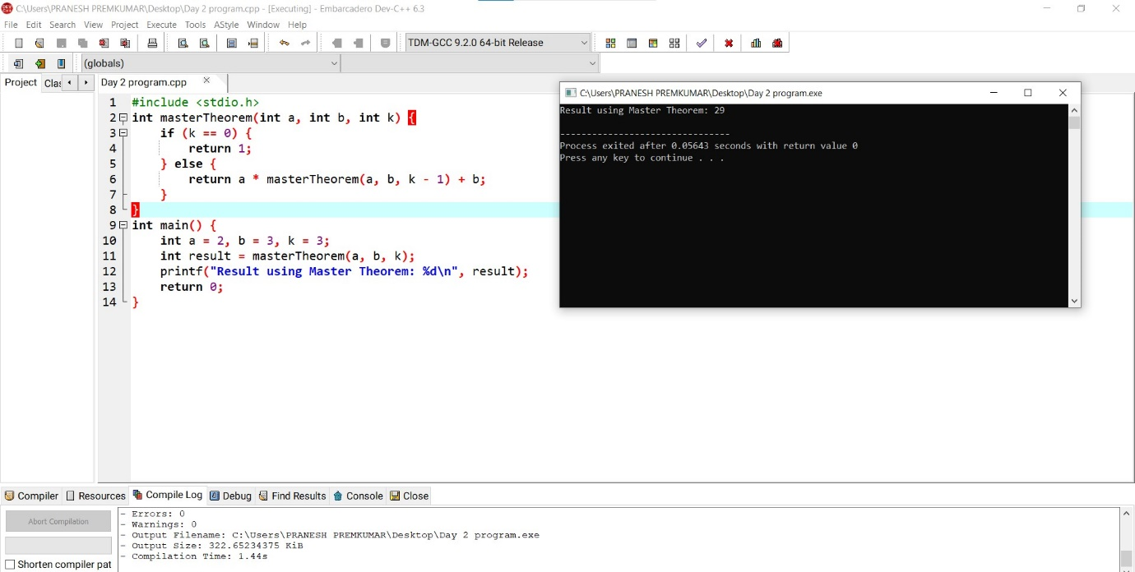

**6.** **Given two integer arrays nums1 and nums2, return an array of their Intersection.**

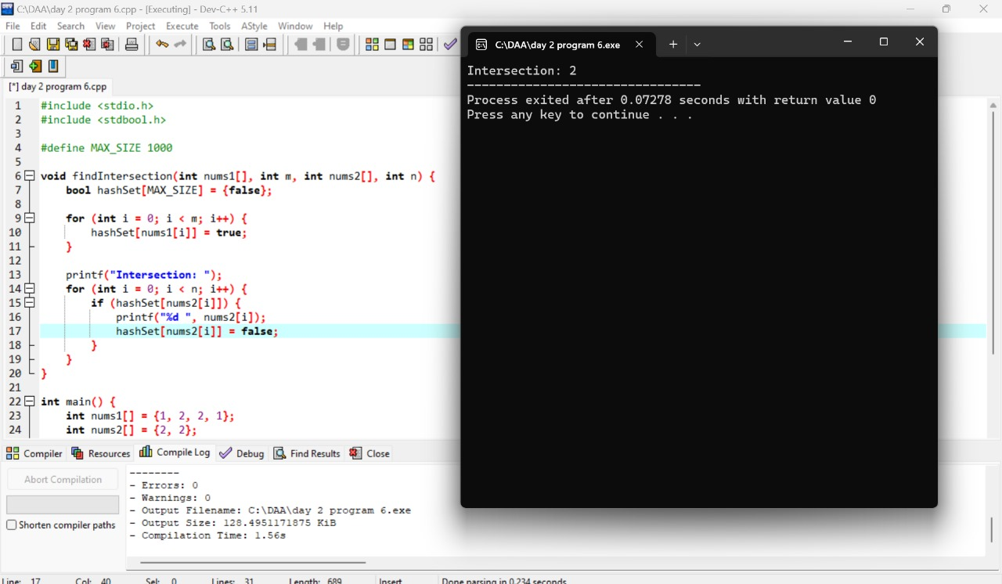

**7.** **Each element in the result must appear as many times as it shows in both arrays and you may return the result in any order.**

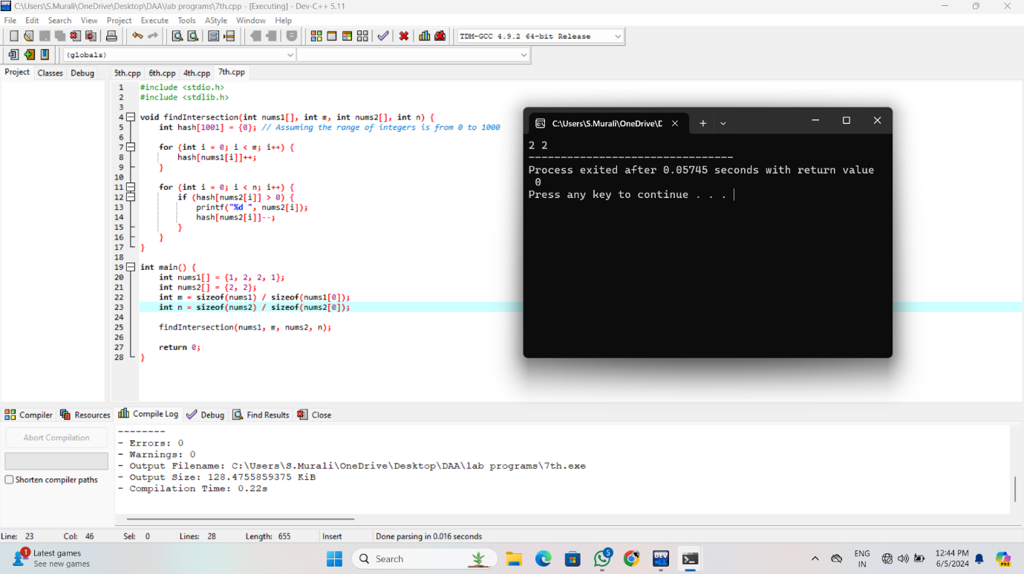

**8.** **Given an array of integers nums, sort the array in ascending order and return it.You must solve the problem without using any built-in functions in O(nlog(n)) time complexity and with the smallest space complexity possible**

**9.** **Given an array of integers nums, half of the integers in nums are odd, and the other half are even.**

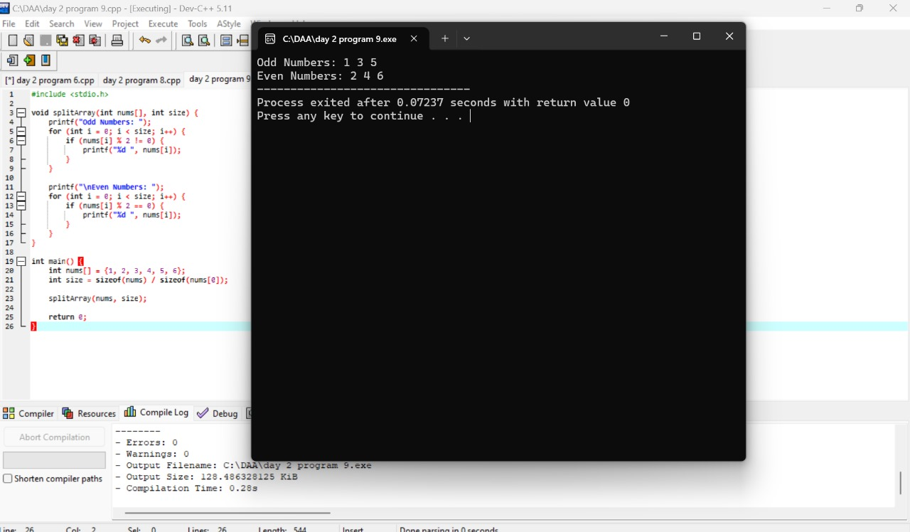

**10.** **Sort the array so that whenever nums[i] is odd, i is odd, and whenever nums[i] is even, i is even. Return any answer array that satisfies this condition.**

